《数据结构》实验报告（二）

学生姓名 李蔚
班 级 计算机2002
学 号 202801108
指导老师 陈 宏 建
成 绩

序号 | 项目名称 | 考核比重 | 得分
1 | 实验预习 | 10%
2 | 实验验收 | 60%
3 | 实验报告 | 30%

2021年 11月 1 日
实验名称： 栈的应用
实验时间： 2021 年 10 月 20 日 第 6 周 星期 三
一、实验预习
1、实验目的
理解并掌握顺序栈和链栈的基本操作及其算法

- 实验内容（包括自己设计增加的内容等）
分别利用顺序栈和链栈实现表达式的计算或计算器。

二、实验报告
1、实验结果（包括程序运行结果、实测数据结果、数据分析等）
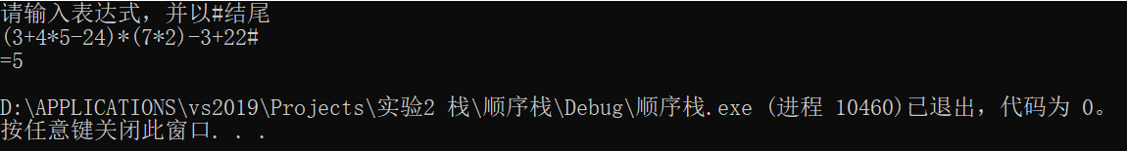
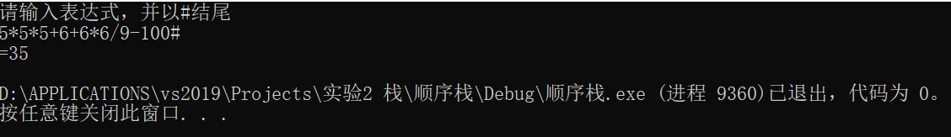
2、实验结论
验证了栈的有关操作。栈是操作受到限制的线性表，它仅在表尾进行插入和删除操作。表尾端称栈顶，表头端称栈底。栈有顺序存储结构和链式存储结构两种表达形式栈的基本操作有初始化，插入，取栈顶元素，判断栈空等等。

附录：（程序源代码）

//顺序栈
Main.c
#define _CRT_SECURE_NO_WARNINGS
#include<stdio.h>
#include<string.h>
#include<stdlib.h>
#include"stack.h"
#include"表达式.h"
int main() {
printf("请输入表达式，并以#结尾\n");
printf("=%d\n", result());
return 0;
}
表达式.h
#pragma once
char prec[7][7] = { ">><<<>>",">><<<>>",">>>><>>",">>>><>>","<<<<<=@",">>>>@>>","<<<<<@=" };
char sign[] = "+-*/()#";
int i = 0;
char precede(char a, char b) {
int i = 0, j = 0;
while (sign[i] != a) i++;
while (sign[j] != b&&j!=7) j++;
if (j == 7) {
printf("表达式错误\n");
exit(0);
}
return prec[i][j];
}
int num(char* a) {
int num = a[i++] - '0';
while (a[i] >= '0' && a[i] <= '9')num = num * 10 + a[i++] - '0';
return num;
}
void operate(stack1*s1,stack2*s2) {
int i = *pop1(s1);
int j = *pop1(s1);
int k;
switch (*pop2(s2))
{
case'+':k = j + i; break;
case'-':k = j - i; break;
case'*':k = j * i; break;
case'/':k = j / i; break;
}
push1(s1, &k);
}
int result() {
stack1* s1 = stack1init();
stack2* s2 = stack2init();
char x = '#';
push2(s2, &x);
char a[128];
scanf("%127s", a);
while (!isempty2(s2)) {
if (a[i] >= '0' && a[i] <= '9') {
int x = num(a);
push1(s1, &x);
}
else
switch (precede(s2->data[s2->top], a[i])) {
case'<': push2(s2, &a[i]); i++;break;
case'>':operate(s1, s2);break;
case'=':pop2(s2); i++;break;
case'@':printf("表达式错误\n"); exit(0);
}
}
int result= *pop1(s1);
free(s1);
free(s2);
return result;
}
stack.h
#pragma once
#define MAXSIZE 128
#define ELEMTYPE1 int
#define ELEMTYPE2 char
typedef struct stack1 {
ELEMTYPE1 data[MAXSIZE];
int top;
}stack1;
stack1* stack1init() {
stack1* s;
s = (stack1*)malloc(sizeof(stack1));
s->top = -1;
return s;
}
int isempty1(stack1* s) {
int x = s->top;
if (x == -1)return 1;
else return 0;
}
void push1(stack1* s, ELEMTYPE1 *a) {
if (s->top == MAXSIZE - 1) {
printf("栈满\n");
exit(0);
}
else {
s->data[++s->top] = *a;
}
}
ELEMTYPE1* pop1(stack1* s) {
if (s->top == -1) {
printf("栈空\n");
exit(0);
}
return &s->data[s->top--];
}
typedef struct stack2 {
ELEMTYPE2 data[MAXSIZE];
int top;
}stack2;
stack2* stack2init() {
stack2* s;
s = (stack2*)malloc(sizeof(stack2));
s->top = -1;
return s;
}
int isempty2(stack2* s) {
int x = s->top;
if (x == -1)return 1;
else return 0;
}
void push2(stack2* s, ELEMTYPE2* a) {
if (s->top == MAXSIZE - 1) {
printf("栈满\n");
exit(0);
}
else {
s->data[++s->top] = *a;
}
}
ELEMTYPE2* pop2(stack2* s) {
if (s->top == -1) {
printf("栈空\n");
exit(0);
}
return &s->data[s->top--];
}
//链栈
Main.c
#define _CRT_SECURE_NO_WARNINGS
#include<stdio.h>
#include<string.h>
#include<stdlib.h>
#include"stack.h"
#include"表达式.h"
int main() {
printf("请输入表达式，并以#结尾\n");
printf("=%d\n", result());
return 0;
}
表达式.h
#pragma once
char prec[7][7] = { ">><<<>>",">><<<>>",">>>><>>",">>>><>>","<<<<<=@",">>>>@>>","<<<<<@=" };
char sign[] = "+-*/()#";
int i = 0;
char precede(char a, char b) {
int i = 0, j = 0;
while (sign[i] != a) i++;
while (sign[j] != b&&j!=7) j++;
if (j == 7) {
printf("表达式错误\n");
exit(0);
}
return prec[i][j];
}
int num(char* a) {
int num = a[i++] - '0';
while (a[i] >= '0' && a[i] <= '9')num = num * 10 + a[i++] - '0';
return num;
}
void operate(stack1*s1,stack2*s2) {
int i = *pop1(s1);
int j = *pop1(s1);
int k;
switch (*pop2(s2))
{
case'+':k = j + i; break;
case'-':k = j - i; break;
case'*':k = j * i; break;
case'/':k = j / i; break;
}
push1(s1, &k);
}
int result() {
stack1* s1 = stack1init();
stack2* s2 = stack2init();
char x = '#';
push2(s2, &x);
char a[128];
scanf("%127s", a);
while (!isempty2(s2)) {
if (a[i] >= '0' && a[i] <= '9') {
int x = num(a);
push1(s1, &x);
}
else
switch (precede(s2->next->data, a[i])) {
case'<': push2(s2, &a[i]); i++;break;
case'>':operate(s1, s2);break;
case'=':pop2(s2); i++;break;
case'@':printf("表达式错误\n"); exit(0);
}
}
return *pop1(s1);
}
stack.h
#pragma once
#define ELEMTYPE1 int
#define ELEMTYPE2 char
typedef struct stack1 {
ELEMTYPE1 data;
struct stack1* next;
}stack1;
stack1* stack1init() {
stack1* s;
s = (stack1*)malloc(sizeof(stack1));
s->next = NULL;
return s;
}
int isempty1(stack1*s) {
if (s->next == NULL)return 1;
else return 0;
}
void push1(stack1* s, ELEMTYPE1* a) {
stack1* p;
p = (stack1*)malloc(sizeof(stack1));
p->data = *a;
p->next = s->next;
s->next = p;
}
ELEMTYPE1* pop1(stack1* s) {
if (isempty1(s)) {
printf("栈空\n");
exit(0);
}
stack1* p = s->next;
s->next = p->next;
ELEMTYPE1 a = p->data;
free(p);
return &a;
}
typedef struct stack2 {
ELEMTYPE1 data;
struct stack2* next;
}stack2;
stack2* stack2init() {
stack1* s;
s = (stack2*)malloc(sizeof(stack2));
s->next = NULL;
return s;
}
int isempty2(stack2* s) {
if (s->next == NULL)return 1;
else return 0;
}
void push2(stack2* s, ELEMTYPE2* a) {
stack2* p;
p = (stack2*)malloc(sizeof(stack2));
p->data = *a;
p->next = s->next;
s->next = p;
}
ELEMTYPE2* pop2(stack2* s) {
if (isempty2(s)) {
printf("栈空\n");
exit(0);
}
stack2* p = s->next;
s->next = p->next;
ELEMTYPE2 a = p->data;
free(p);
return &a;
}

